**FOOD NUTRIENT PROFILE REPORT**

**OBJECTIVE**

The objective of this Power BI dashboard is to provide a comprehensive and visual analysis of food nutrient profiles using a large dataset of food items. The dashboard enables users to:

* Identify top high-calorie foods and analyze their detailed nutrient composition (calories, fats, proteins, carbohydrates).
* Understand the distribution of food items across different categories (e.g., Meat, Dairy, Fruits, Vegetables).
* Monitor and compare total and average calorie values across food items.
* Assess sodium and potassium balance across nutrient status groups.
* Analyze mineral content (Calcium, Iron, Folate, etc.) by food category to support dietary planning.
* Gain insights into the nutritional quality of food items based on fiber and protein content.

**3. Data Overview**

Source of the dataset

The dataset used for this dashboard contains **8,790 records**, with each record representing a unique food item. It includes multiple nutritional variables critical for dietary analysis. Key fields in the dataset include:

**Energy_Kcal**: Total caloric value of the food item.

**Food_Category**: Classification of the food (e.g., Meat, Dairy, Fruits, Vegetables).

**Protein (g)**: Protein content in grams.

**Fat (g)**: Total lipid content.

**Sodium (mg)** and **Potassium (mg)**: Essential minerals for sodium-potassium balance.

**Carbohydrates (g)** and **Fiber_Category**: Important for analyzing energy sources and dietary fiber levels.

**Calcium (mg)**, **Iron (mg)**, **Folate (µg)**: Key micronutrients for mineral content analysis.

**DAX QUERIES**

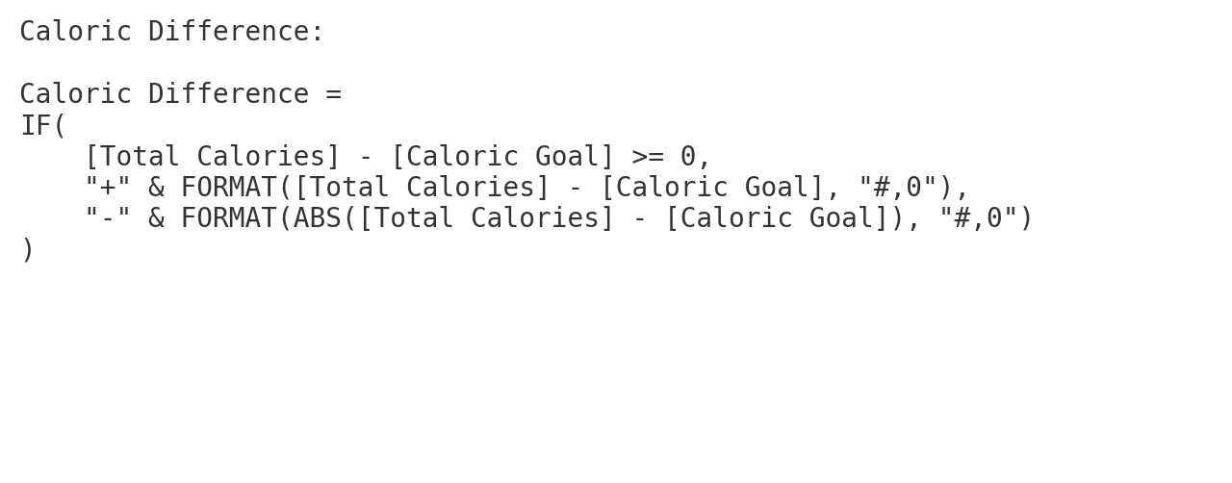

**Purpose:**  
 Calculates the difference between actual total calorie intake and a user's goal. It adds a "+" or "-" to visually show if the goal was exceeded or not.

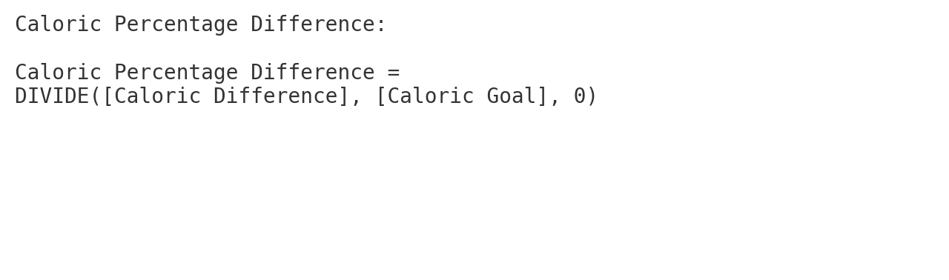

**Purpose:**  
 Computes how far off the total calories are from the goal in percentage terms. DIVIDE safely handles division by zero

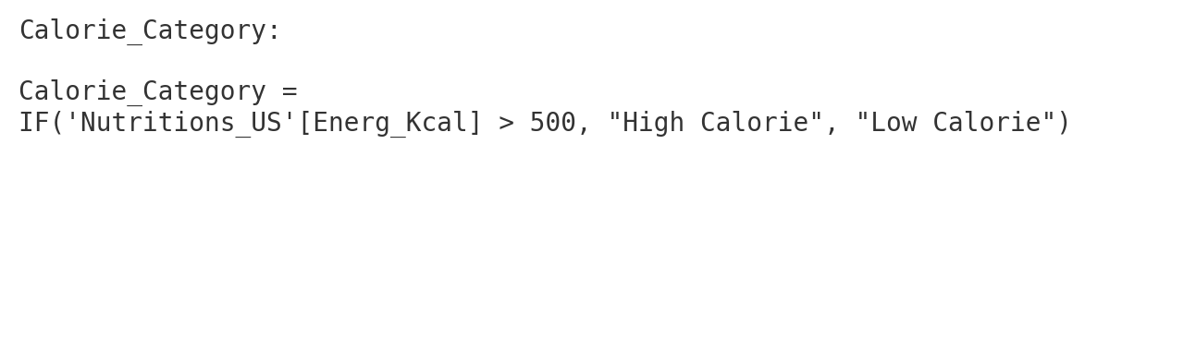

**Purpose:**  
 Classifies each food item as either high-calorie or low-calorie based on a 500 kcal threshold for simplified analysis.

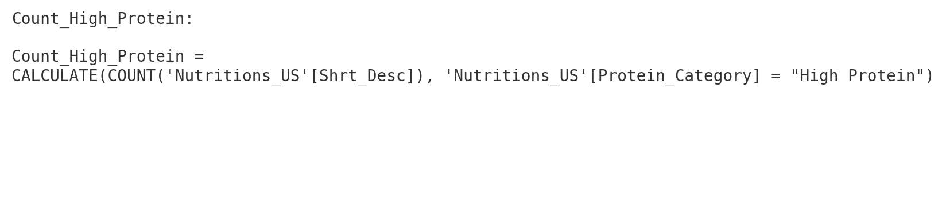**Purpose:**  
 Counts how many food items fall into the "High Protein" category — useful for summarizing protein-rich foods.

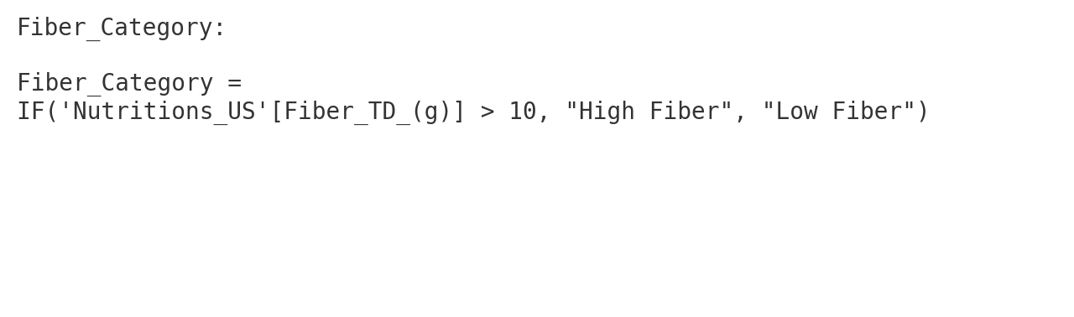

**Purpose:**  
 Labels foods as high or low in fiber based on a 10g threshold to support fiber-specific filtering and comparison

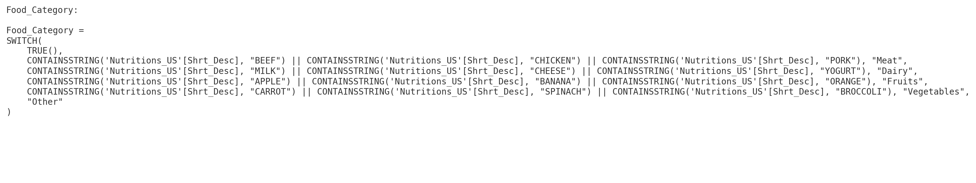**Purpose:**  
 Automatically groups food items into categories based on keywords in their names. This helps in category-wise filtering and analysis.

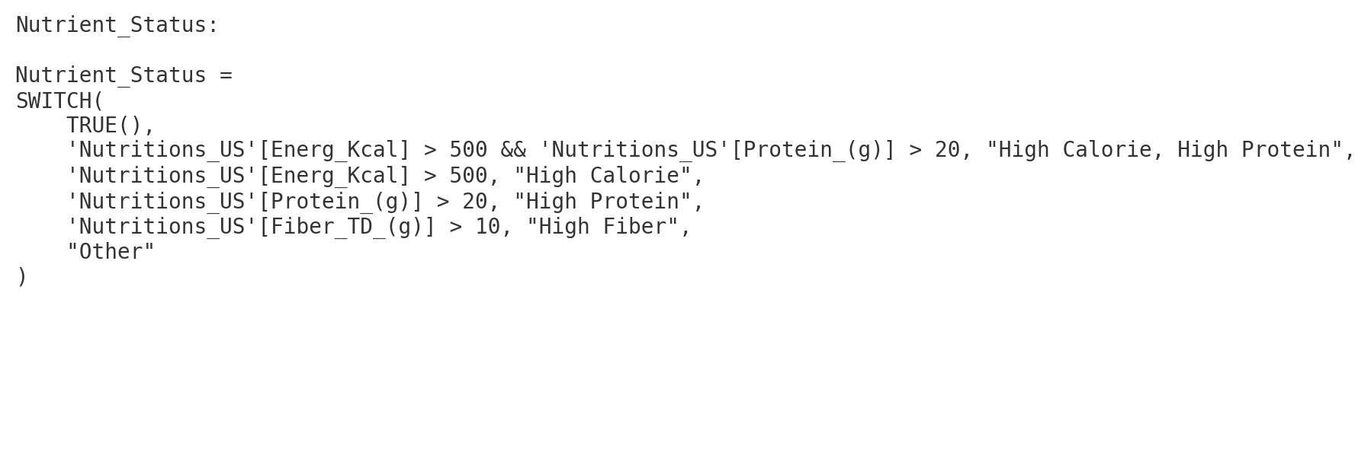**Purpose:**  
 Creates a multi-criteria classification based on calories, protein, and fiber, enabling richer nutrient analysis.

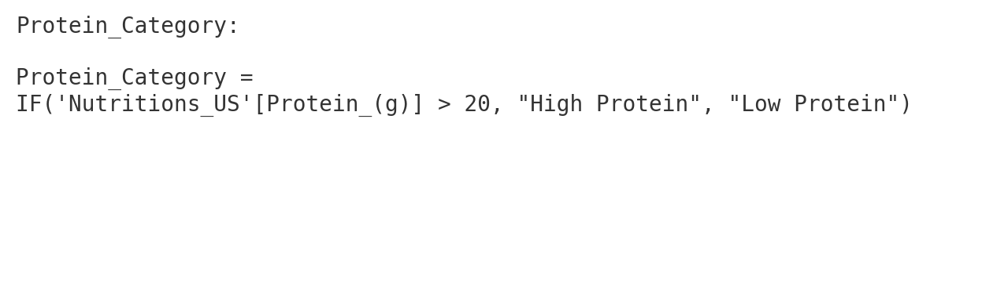

**Purpose:**  
 Labels foods as "High Protein" or "Low Protein" based on 20g threshold — simplifies protein-level breakdowns.

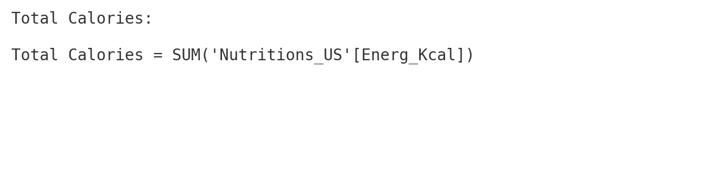

**Purpose:**  
 Calculates the total caloric content across all foods in the dataset. Used for overall summaries and comparisons.

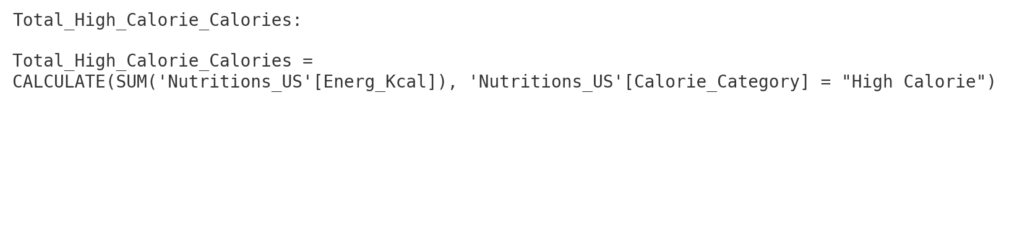**Purpose:**  
 Sums the calories of only the high-calorie foods — used to quantify how much high-calorie foods contribute to total energy.

### **4. Dashboard Summary**

#### **Page 1: Food Nutrient**

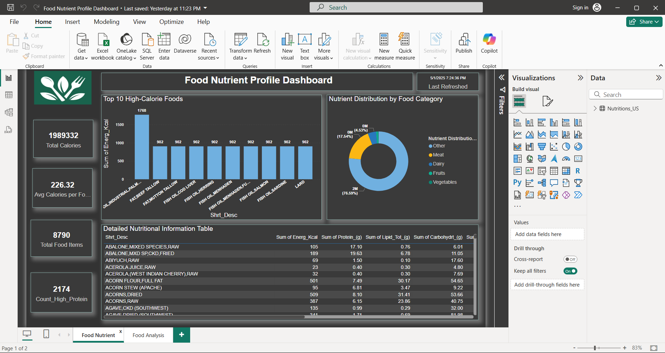

**Visuals Used:**

1. **Bar Chart** – Top 10 High-Calorie Foods
   1. Displays food items with the highest calorie content based on the Energ_Kcal field.
2. **Donut Chart** – Nutrient Distribution by Food Category
   1. Shows the percentage distribution of calories among categories like Meat, Dairy, Fruits, and Vegetables.
3. **Card Visuals** –
   1. **Total Calories** – Displays the total calories from all food items (1989332 kcal).
   2. **Avg Calories per Food** – Shows the average calorie count per item (226.32 kcal).
   3. **Total Food Items** – Total number of entries (8790).
   4. **Count_High_Protein** – Total number of foods labeled as high-protein (2174).
4. **Table** – Detailed Nutritional Information Table
   1. Shows food names and detailed nutrient breakdown (Energy, Protein, Fat, Carbs, etc.)

**Filters/Slicers Available:**

* **Food_Category** – Lets the user select categories like Meat, Dairy, Fruits, Vegetables, or Other.
* **Sum of Energ_Kcal** – Optional slicer for calories.
* Global page filters: GmWt_Desc2, Protein_Category, Shrt_Desc

#### **Page 2: Food Analysis**

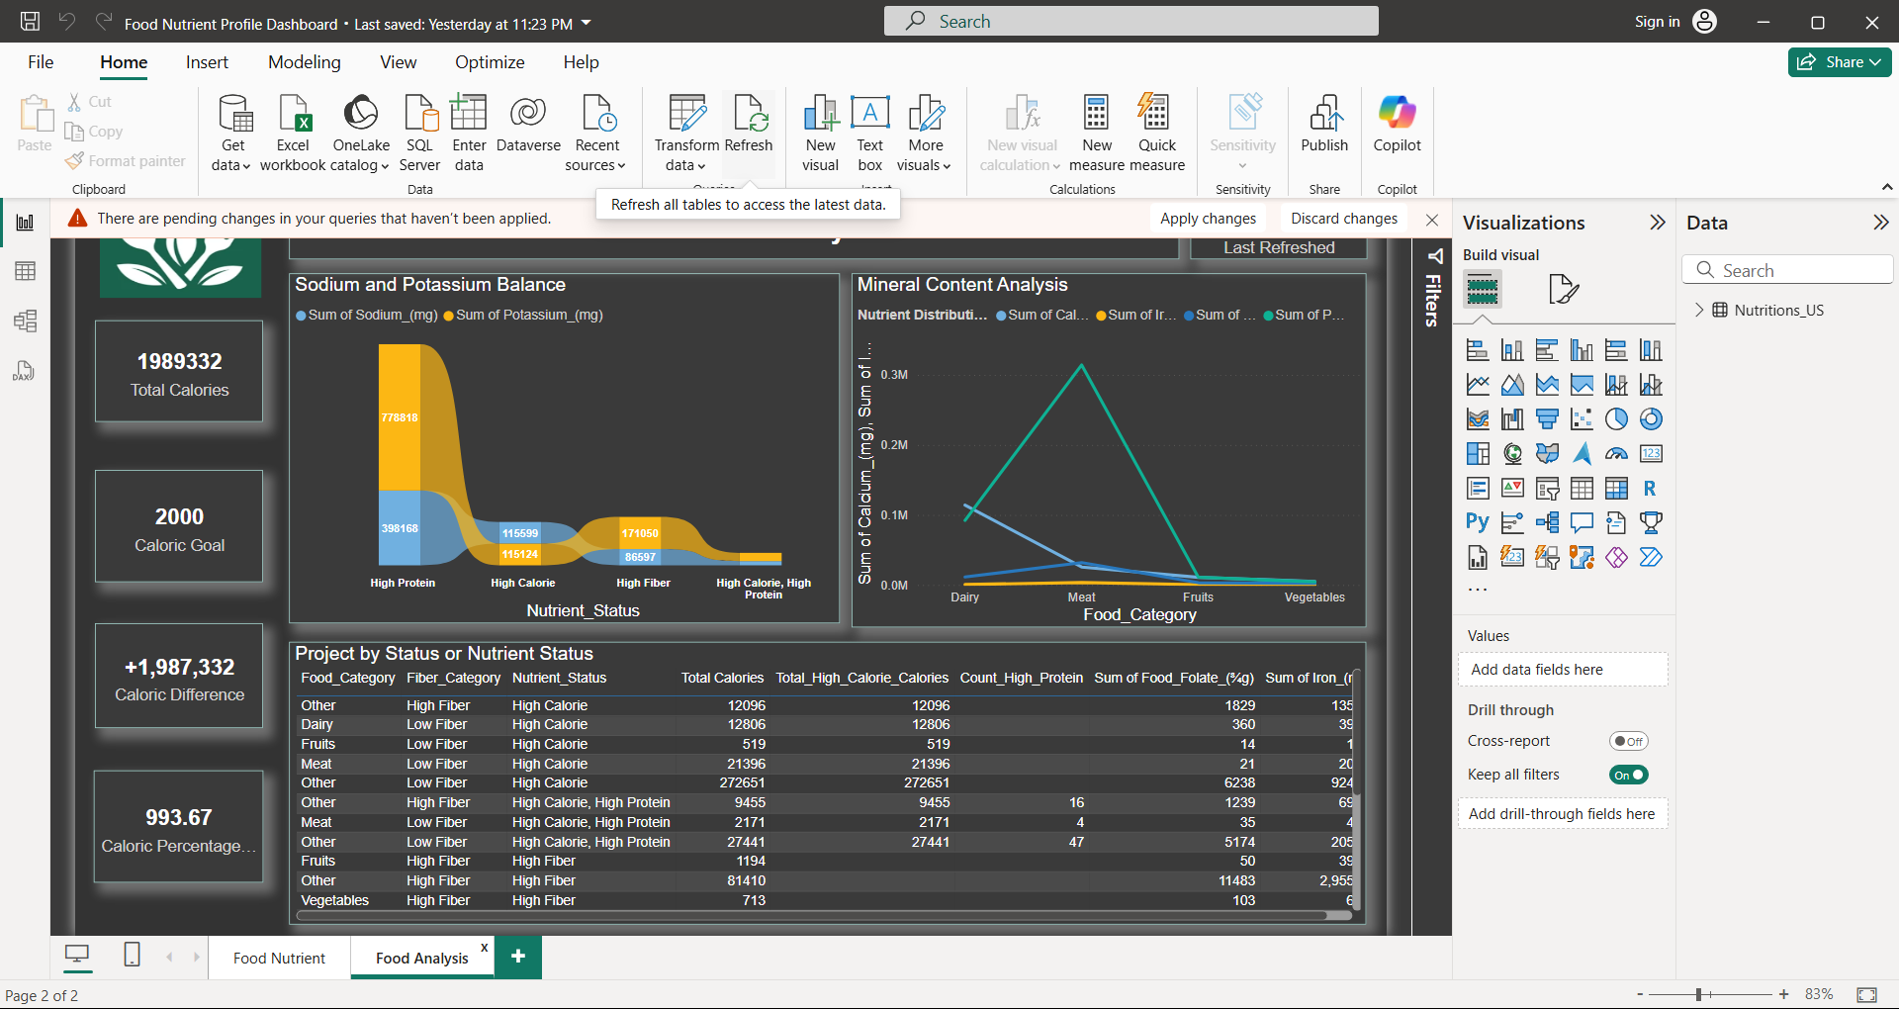

**Visuals Used:**

1. **Stacked Area Chart** – Sodium and Potassium Balance
   1. Compares sodium and potassium levels across different nutrient status types (e.g., High Protein, High Fiber).
2. **Line Chart** – Mineral Content Analysis
   1. Plots total minerals (Calcium, Iron, etc.) across food categories to compare nutritional value.
   2. **Card Visuals** –**Total Calories**
   3. **Caloric Goal** – (2000 kcal target)
   4. **Caloric Difference** – Difference between total calories and goal.
3. **Table** – Project by Status or Nutrient Status
   1. Breaks down foods by category, fiber level, and custom nutrient status. Shows total calories, protein counts, and minerals.

### **5. Key Findings / Insights**

#### **Top High-Calorie Foods and Their Composition**

* The bar chart on Page 1 shows the top 10 high-calorie foods, led by Oil, Industrial Palm Kernel (Hydrogenated), Confection Fat with 1768 kcal.
* Most of these foods are oils and animal fats with **high lipid content (200g)** and **zero protein/carbs**, indicating they're purely fat sources.

#### **Caloric Distribution by Food Category**

* The donut chart reveals that the **Meat category dominates** total caloric contribution (76.59%), followed by Dairy (17.54%) and Fruits (4.53%).
* This suggests that meats are the primary energy source in the dataset.

#### **Nutrient Status Comparisons (e.g., High Fiber vs. Low Fiber)**

* The table and chart on Page 2 show comparisons across nutrient statuses:
  + High Fiber foods have noticeably **lower calories** but **higher mineral content**.
  + High Calorie, High Protein foods are often **meat-based**, with higher iron and protein levels.

#### **Sodium and Potassium Imbalances**

* The stacked area chart shows **disproportionately high sodium levels** compared to potassium, especially in High Protein and High Calorie foods.
* This imbalance suggests potential health risks in diets heavy in such foods.

#### **Mineral Content Trends Across Food Groups**

* The line chart displays that **Meat has the highest iron and folate content**, while **Dairy is highest in calcium**.
* Vegetables lag in total mineral values, possibly due to lower representation or portion sizes in the dataset.

### **6. Conclusion**

#### **Summary of Main Takeaways**

* High-calorie foods are primarily fats and oils, contributing massively to total energy with little nutritional balance.
* Meat dominates in both calorie and protein contribution.
* Foods classified as high fiber or high protein show better mineral profiles but can also carry higher sodium.
* Clear nutrient imbalances (e.g., sodium > potassium) highlight dietary risks.

#### **How the Dashboard Can Be Used**

* **Health & Nutrition Planning**: Identify foods high in beneficial or harmful nutrients.
* **Public Awareness**: Educate consumers on calorie-heavy and nutrient-rich foods.
* **Policy Making**: Assist food regulation and labeling based on nutrient density and risk.

#### **Limitations**

* Food categorization is based on **keyword matching**, which may misclassify some items.
* The dataset lacks **portion size context** and **daily intake relevance**.
* Data may not be fully representative of real-world diets or food availability.